Phoenixville Area High School Advanced Women's Choir and Select Vocal Ensemble

May 3, 2015

4:00pm

*The Vocal Ensemble is an audition-only choral ensemble of the highest caliber.  This ensemble is for students who are highly motivated and self-directed and who wish a musical experience at an intense level.*

Jazz and Joe

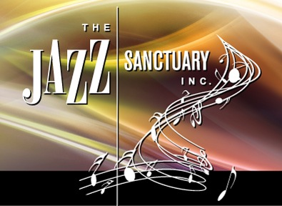

is pleased to announce our 2014-2015 concert series. Concerts in this series are open to the public, however a free-will offering to support this series is requested ($5.00). The series is entirely funded by donations and free-will offerings.

April 19, 2015

4:00pm

**The Alan Segal Quartet** presents coffee house style Jazz music for your enjoyment. Come out and have a cup of Joe and enjoy and afternoon of relaxing and uplifting Jazz music.

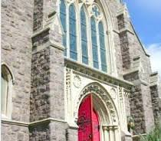

music @ st peter’s

Our very own Trevor Gordon Hall will do a joint concert with Adam Monaco. Trevor Gordon Hall sets himself apart by leaving no physical aspect of the guitar untouched and weaving together different textures into grand yet intimate and lyrical compositions. His blend of each sound doesn’t overcomplicate but focuses on utilizing the instrument’s fullest creative and compositional potential.  Adam Monaco, based out of Philadelphia fuses many different styles and

influences to expand the horizons of traditional singer/songwriter music.

His upbeat and lyrical blend of folk rock has engaged audiences regionally

and nationally, and has shared the stage with many well-known names

throughout the world.

2014-2015 Concert Series Finale

May 31, 2015

4:00pm

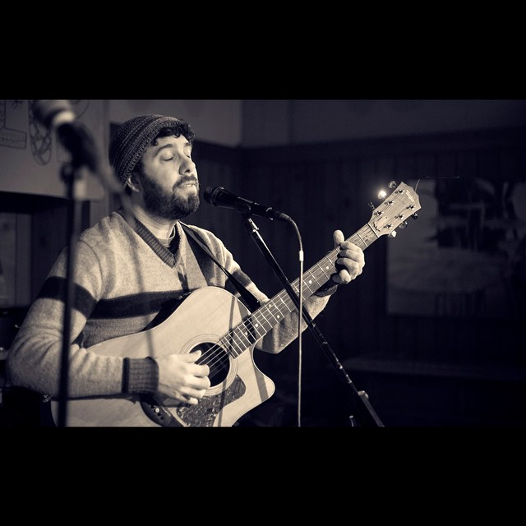

Ascension Day

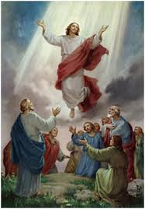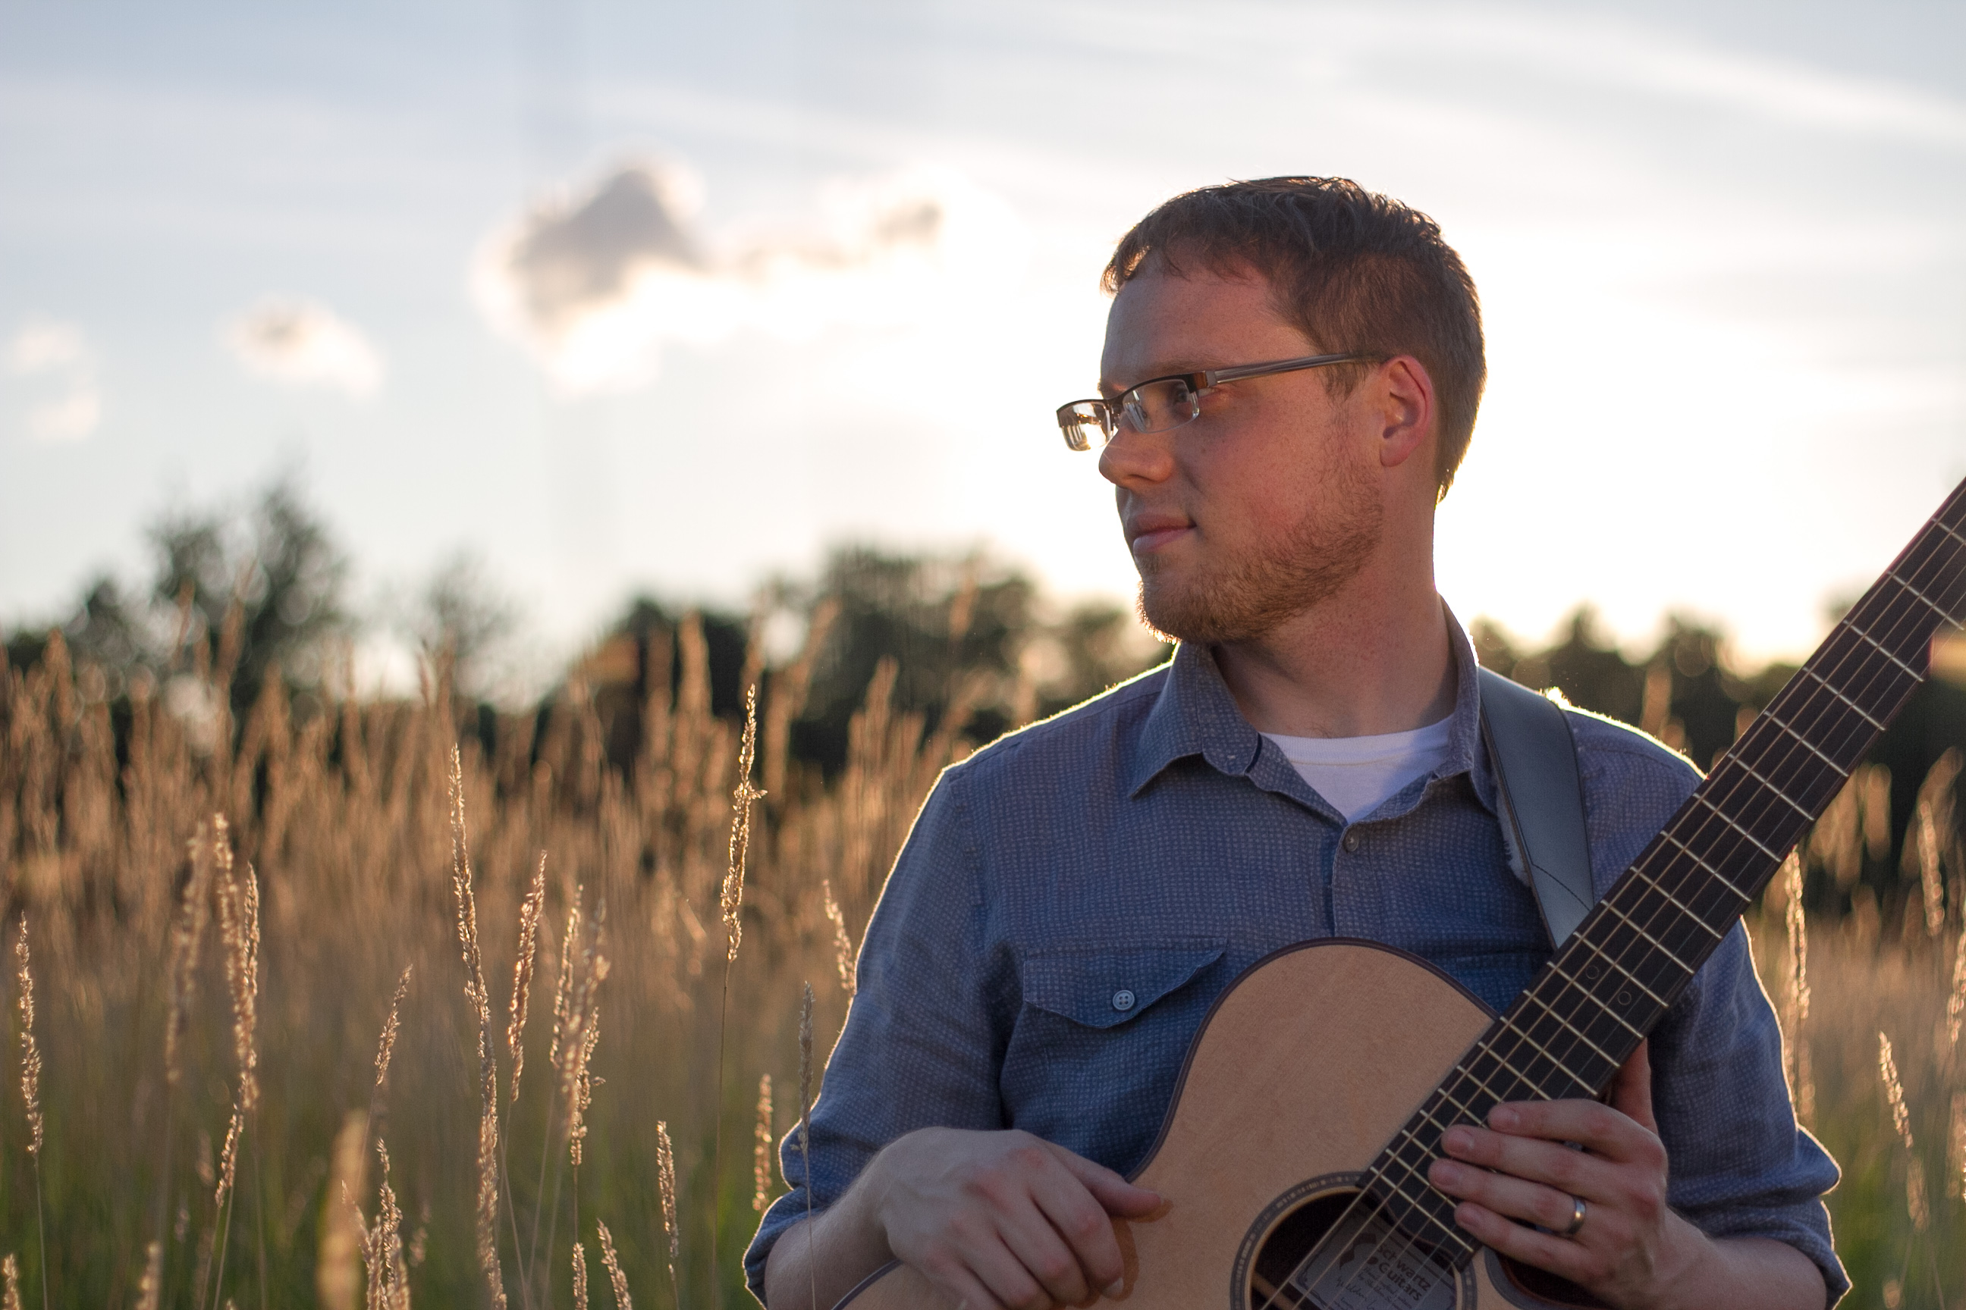

Trevor Gordon Hall and



Adam Monaco

May 14, 2015

7:30pm

Come join us at St. Peter’s for an evening of commemoration for the ascension of Christ into Heaven.