Dear Parishioner,

Thank you for your generosity in contributing to St. Peter’s Episcopal Church. For parishioner online giving we use [ChurchTrac](https://specphx.churchtrac.com/give), accessible via your internet browser.

ChurchTrac online giving ensures you receive proper credit and reporting for your donations.

By giving online, you also reduce the work of the Counters who handle cash and checks given in the Sunday collection plate, and as well as for Judy Dougherty our parish Secretary, and Dennis Reid, our Accounting Warden.

It also provides electronic data that ensures your donations are allocated to your intended funds and purposes, especially important if you are fulfilling a pledge.

The most cost-effective way to contribute is to set up direct debit payments from your Checking Account. To do this:

1. Login/Sign In to the ChurchTrac application at <https://specphx.churchtrac.com/give>.
   1. You can also access this link from the **Give** menu option on the St Peter’s website Home page.
   2. Login/Sign In instructions are described below in Step 1.
   3. For first users, create an account for yourself; see Steps 2-5.
2. At the main giving screen, define your giving Category(s), Amount(s), frequency (single or recurring), and start date; see Steps 6-15. You also have the option to add a Memo and/or assign multiple Categories for a single payment or set of recurring payments.
3. At the main giving screen, set up a Payment Method within ChurchTrac; this is a one-time action; see Steps 16-21.
   1. We greatly appreciate if you pay from your Checking account, not PayPal or a debit/credit card where 3% of the amount is lost to transaction fees, compared to 25 cents if you pay (via ACH) from your Checking account.
4. Important! ChurchTrac does not allow you to change an existing or future donation, only to cancel and create a new payment or new scheduled set; see Steps 22-24.
5. Note: St. Peter’s gives you credit for the amount you donate, regardless of the transaction fees deducted from your donation.
6. Note: You will receive emailed giving statements from the church office, unless you ask to stop them.

Any questions, contact Leo Guen at [leotguen@gmail.com](mailto:leotguen@gmail.com) or (718) 764-3503.

Thank you.

The St. Peter’s Stewardship Ministry team

Dennis Reid – Ministry Leader Diane Hope

Leo Guen – ChurchTrac system administrator Frank Rothenberger

Judi Hans Robert Gauthier

Follow these instructions to Create an Account and sign in to the ChurchTrac application.

Step 1: To access Online Giving in ChurchTrac and Sign In, go to <https://specphx.churchtrac.com/give>.

You can also get to [ChurchTrac](https://specphx.churchtrac.com/give) via the [St Peter's home page](https://saintpeterschurch.net/) **Give** menu option…

… that displays the ["Donate to St Peter's" webpage](https://wp.me/P7BM3j-TP) and a link to ChurchTrac:

Step 2: If it is your first time in ChurchTrac, you will need to click Create an account. When you create an account, ChurchTrac first wants to protect itself from hacking. Click the box for “I’m not a robot” and the “Continue” button.

Step 3: You will be notified to check your email for a temporary password. Enter this temporary password in the Sign In screen “Your Password” field below your email address and click “Continue”.

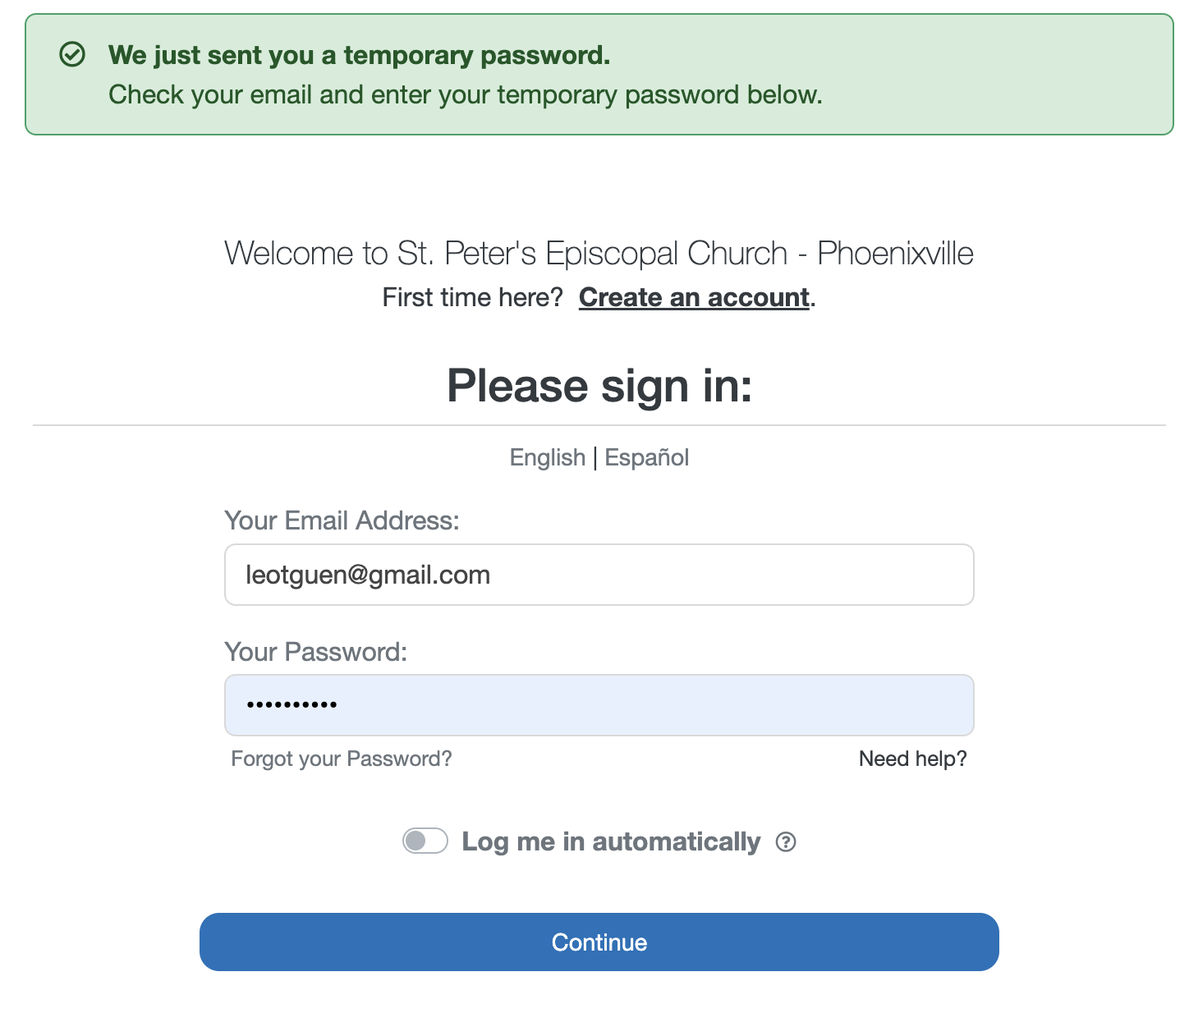

Step 4: You will be asked to create a strong password and re-type it. Then click “Submit”.

Step 5: After the system accepts your new password, click “OK” to continue.

You will be shown the ChurchTrac Online Giving screen, where you will first need to enter details for your first payment or set of payments before identifying a new Payment Source, e.g., checking account.

Step 6: An “Enter Payment Details” button will appear for you to click on.

Step 7: Now is the time to select your Giving Category(s), Amount(s), and an optional Memo.

When selecting the Category you want to donate to, there are ten (10) Categories/purposes to choose from.

* These are: Pledge Giving; Open Plate Giving (general purpose); Rector’s Fund Giving; Cristosal (Cristosal Foundation); Youth Group Fundraising; Altar Guild Donation; Flowers Donation; Outreach Donation; Memorial Donation; and Other Donation.

Step 8: To add a Memo to describe a specific purpose or details, click the “+” sign at the right of the Category drop-down field. This is especially important for Memorial or Other donations.

Step 9: Clicking the “+” sign displays a window to enter a Memo to communicate or record extra details, e.g., purpose, special intentions, catch up. The Memo applies to a one-time donation or recurring set of donations. Clicking “Close” returns you to the previous screen.

Step 10: You can split your donation and give to multiple Categories in a single transaction by clicking the “+ Add another” link. When completed, click “Close”.

Step 11: If splitting your donation among multiple Categories, you will see the total donation amount and “Multiple Entries”.

Step 12: Now that you have specified the Amount(s) and Category(s) and an optional Memo, it’s time to decide if you want to Give Once or to make a Repeat/Recurring donation.

Step 13: This example of a one-time donation shows the “Give Once” button was clicked.

Step 14: For recurring donations, you have the option of weekly, bi-weekly, or monthly.

For example, a recurring monthly donation to Cristosal would look like this:

Step 15: Now that Payment Details are completed, it’s time to set up a Payment Source. To do this, click the “Enter a New Payment Source” button under the “Choose a Payment Source” text.

The screen defaults to pay by “Card”.

Step 16: To debit your Checking or Savings account (pay via ACH), click “US bank account”, enter your email address and name, and find your bank so that Stripe (ChurchTrac’s payment provider partner) can access your bank account.

Step 17: After you have connected to your bank account online and verified your identity, Stripe will give you the option to choose one of your bank accounts. Select an account and click “Connect account”.

Step 18: Stripe will confirm your selected account is now connected to ChurchTrac Online Giving. Click “Continue” to return to ChurchTrac Online Giving.

Step 19: After returning to ChurchTrac, the Online Giving screen shows your Bank Account will be charged for your donation amount if you click the “Charge” button.

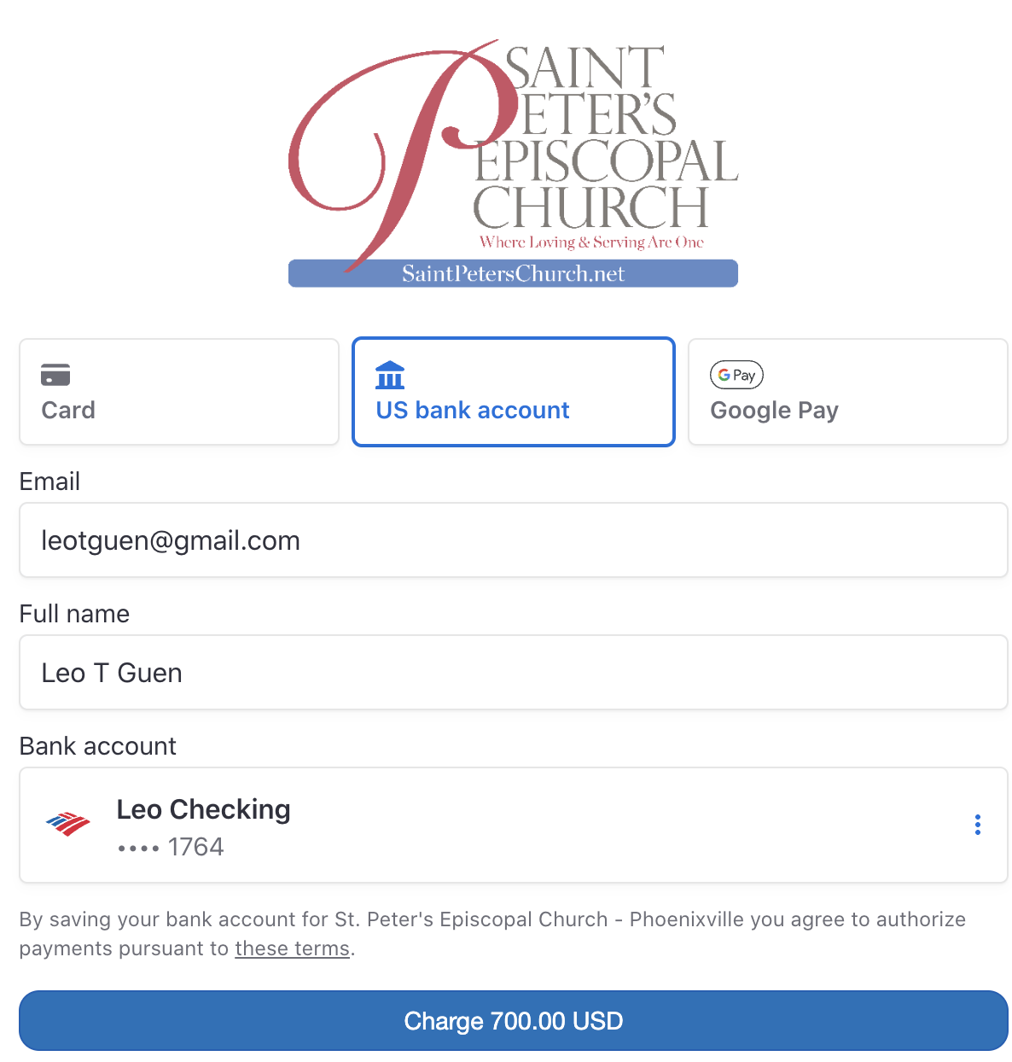

Step 20: You will see a transaction confirmation, with the option to return to Online Giving.

Step 21: The next time you come to the Online Giving screen, you can use the Bank Account you set up; the Bank Account set up is a one-time action.

Canceling / Stopping a payment

ChurchTrac does not allow you to update/amend future single or recurring/scheduled payments. ChurchTrac only allows you to cancel/delete a single payment or an entire set of recurring payments, after which you must create a new payment or new scheduled set of payments.

Step 22: To cancel/delete a future payment or scheduled set of payments, click the cog icon on the main giving screen.

Step 23: This will display a right sidebar window displaying a payment or scheduled set of payments to cancel. Click on the “’x” to begin the cancellation process for the payment(s) you want to cancel. If you don’t want to cancel, click the “Close” button at the bottom of the right sidebar.

Step 24: To confirm you want to cancel the single or recurring set of payments, click the “Yes, Cancel” button. Else click the “Close” button or “x” to return to the previous screen.

